OPERATION BEE

Lesson Plans
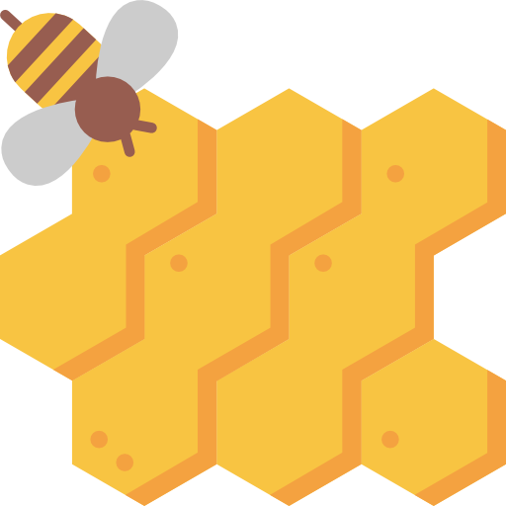

Icon made by www.freepik.com licensed CC BY 3.0

This curriculum was created by 9th grade students at Mountain Heights Academy. The intent was to help educate students on the benefits of bees, encourage the creation of bee nesting boxes and to collect data on bee activity. This project is aligned to SEEd standard 6.4.
Core Standard: 6.4 Stability and Change in Ecosystem. The study of ecosystems includes the interaction of organisms with each other and with the physical environment.

CC-BY 3.0 Lesson Materials created by Mountain Heights Academy: Emma Davis, Lora Gibbons, Kate Larson, Donna Trane, Kyana Trane, Sarah Weston

Activity 1: Bee-coming Familiar with Bees
Duration of time: 1 hour

Objectives:
- Students will identify 3 benefits to bees
- Students will learn about 3 types of bees and common characteristics and 3 types of common wasps and the differences
- Students will identify why bees and wasps can be considered pests
- Students will discuss how to help bees
- Students will observe bees and wasps

Materials:
Lab Manual (with pictures) and information
Plantar box or garden area to observe

Lesson:
Students will learn about bees and wasps and then discuss as a class how to identify them. Discuss why bees and wasps can be considered pests, but why they are crucial to our environment. Such discussion could include: Then spend time observing your surrounding outside area including plantar box for wasps and bees. Be careful to not disrupt them, stings are painful and can cause problems.
- Bees and wasps are often grouped together because they are of the same order (Hymenoptera)
- Bee pollination habits affect between 50-80% of the world’s food supply (http://www.insectidentification.org/bees-ants-wasps-and-similar.asp)
- Although wasps aren’t as good as pollinators as bees they still do pollinate
- Many wasps control other pest insect species including common garden pests, spiders, etc. https://www.extension.umn.edu/garden/insects/find/wasp-and-bee-control/
- Some wasp nests have been used in Chinese medicinal uses
- Additional identification and pest resource: http://www.pestworld.org/news-hub/pest-articles/stinging-insects-101/

Spend time allowing students to identify their surroundings. Typically, 10 minutes is ample time for them to survey their surroundings. This day specifically look for types of bees and wasps. See how many the students can identify. If a camera is available take pictures. Also, count how many total number of bees are seen.

Follow up discussion:
Ask students why bees are important, list their responses
Ask students if wasps are good or bad and why?
Discuss how ecosystems rely on several organisms each fulfilling their role.
What role does the bee play in our ecosystem?

Activity 2: Solitary Bees & Engineer a Bee Nesting Box

Duration of time:
1-2 hours over a couple of days (this will depend on how you structure this assignment and if you have the students bring in supplies to physically build their native nesting box)

Objectives:
- Students will identify 3 characteristics of solitary bees
- Students (or groups of students) will discuss ideas for constructing a DIY native nesting box.
- Students (or groups of students) will use basic supplies to engineer a native nesting box

Materials:
Student manuals
If students decide to build their bee nesting box it will require additional supplies (but this is optional, and the student’s choice)

Lesson:
Solitary bees comprise the majority of bees and yet are typically not recognized. These bees do not form colonies or live in hives, but rather nest alone. (http://www.buzzaboutbees.net/solitary-bees.html)
During this project, students will follow the student manual to design their own native nesting box. Students are encouraged to use their creativity in this design process. Students can work alone or in small groups during the design process. Teachers can decide if they want students to physically build their design (fulfilling standard 6.4.3 Develop a model)

Follow-up Discussion:
What part was difficult in the design phase? Why?
What materials worked best for solitary bees and why?
What natural occurrences could damage your native nesting box?
What would you change if you could re-engineer your native nesting box.

Activity 3: Observe and Collect Bee Data

Duration of time:
2-3 weeks (5-10 minutes/day after initial lesson - 20 minutes)

Objectives:
- Students will identify types of pollinators found in plantar box and surrounding flowers.
- Students will identify types of pollinators
- Students will observe behaviors and count numbers of bee-like pollinators
- Students will identify sources of food for pollinators

Materials:
Student lab manual
Plantar box or garden area for observation

Lesson:
Discuss with students why it is important to know how to collect data before collecting data. Discuss best practices for collecting data. Encourage students to consider what could affect data collection.

Topics of discussion:
Keeping collecting consistent (amount of time, location, does weather play a role, etc.)
Observing without touching (especially when dealing with bees)
Data over a longer time period is more conclusive

Then have students (or groups of students) observe plantar box and surrounding areas. Fill out the data table in the student section. Spend a small amount of time each day collecting data (one group could be assigned each day or several groups). If possible, observe in the morning and afternoon. Make sure to record your data. Data should be kept for a minimum of 2 weeks.

Follow-up Discussion:
Each day compare the data to the previous day’s data. Look for trends in the data. Are there more pollinators in the morning or afternoon? Why? Does weather play a role? Why is observation so important in collecting data? What would happen if you had to collect data blind?

Activity 4: Share your Data

We believe in Open Education Resources and the use of Creative Commons Licensing to openly share data and teacher materials. Open Educational Resources (OER) are teaching and learning materials that you may freely use and reuse at no cost, and without needing to ask permission.

Learn more about Open Educational Resources at https://www.oercommons.org
Learn more about Creative Commons Licensing at https://creativecommons.org

We are collecting data nationwide and are requesting participating schools/students share back their data and project documentation.

Please share any collected data and photographs with Mountain Heights Academy by emailing:

bees@mountainheightsacademy.org

In your email, please indicate that you are Creative Commons (CC BY 3.0) licensing your data and photographs and indicate the name of the student, teacher or organization the license will be held by.

