OPERATION BEE

Mission Folder
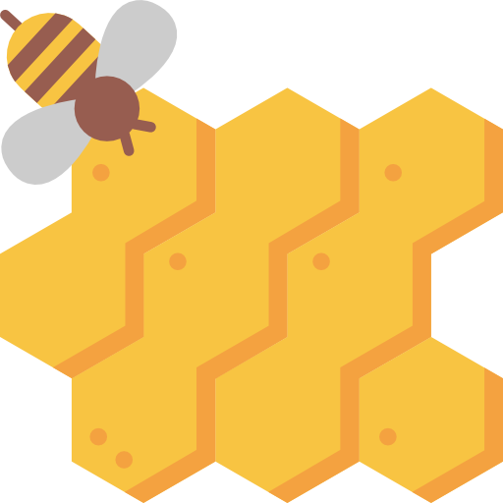

Icon made by www.freepik.com licensed CC BY 3.0

Name: __________________

Mission Checklist:

Bee-coming Familiar with Bees

All About Solitary Bees

Engineer a Native Nesting Box

Observe and Collect Bee Data

CC-BY 3.0 Lesson Materials created by Mountain Heights Academy: Emma Davis, Lora Gibbons, Kate Larson, Donna Trane, Kyana Trane, Sarah Weston

Bee-coming Familiar with Bees

There are many bees in our environment and it can be hard to tell whether they are friend or foe. This chart can help you identify bees and understand their behavior and how they benefit our environment.

Bee Type | Habitat | Looks | Behavior
Bumble Bee  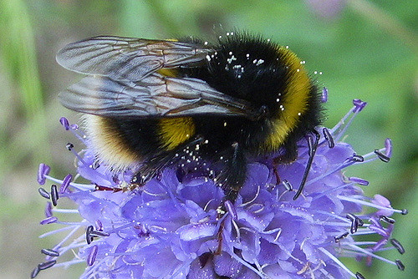  CC BY-NC-SA 2.0 by Rob Rover | Usually nest in dark areas or in the ground.  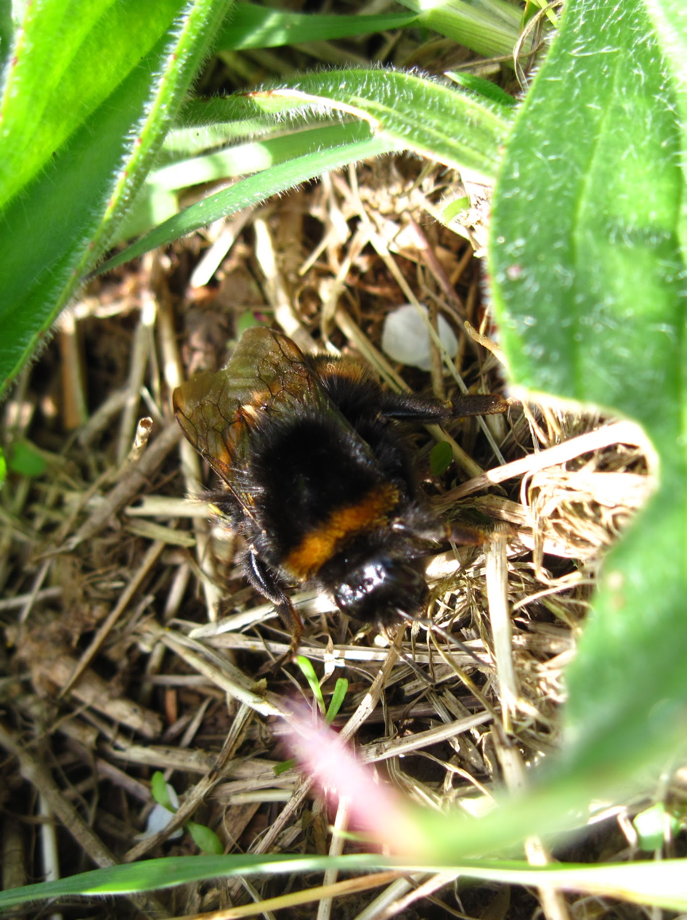  CC BY-NC 2.0 by joysaphine | Very fuzzy. Bigger than the honeybee and have white on their stinger. | Like honey bees, they pollinate flowers and eat nectar. They can sting more times when agitated.
Honey Bee  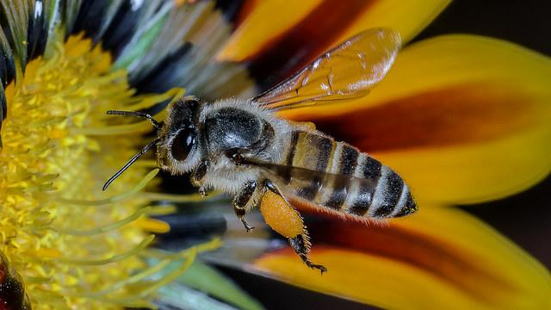  CC BY-NC-SA 2.0 by ncdslr | They prefer a strong home such as a tree, wall, or attic. They make their homes out of wax.  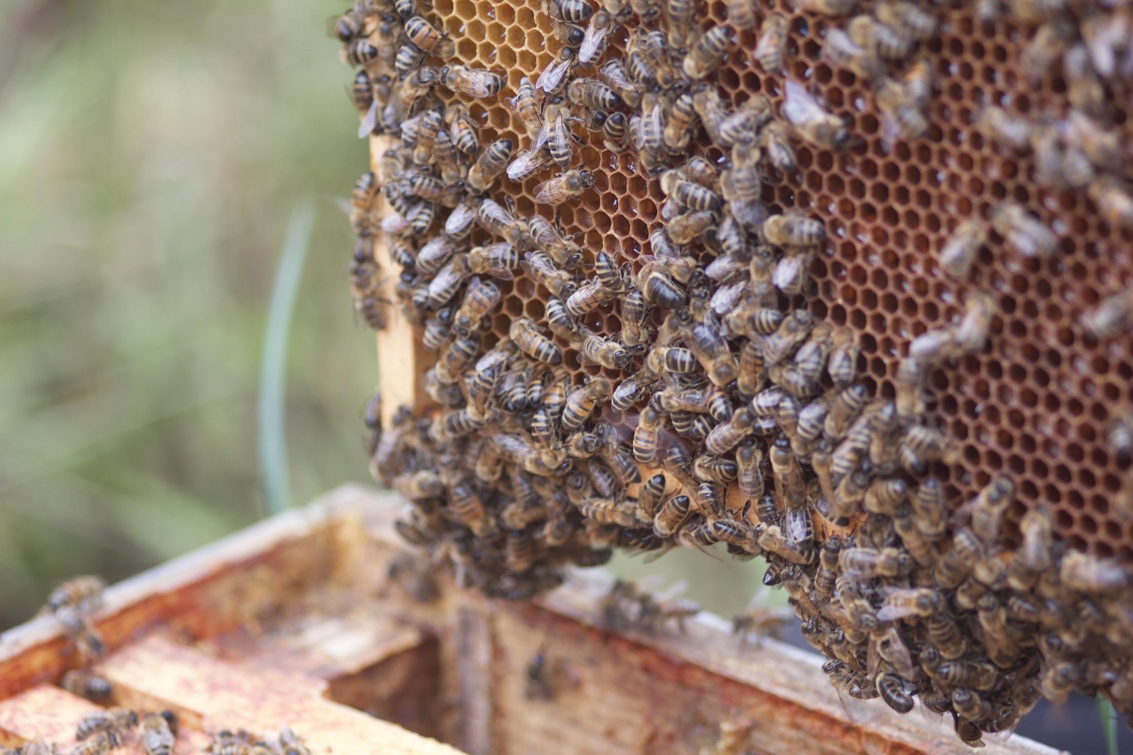  CC BY-NC-SA 2.0 by stevenbates | Yellow-orange type of color. Has thin black stripes. | Makes and stores honey. Pollinates flowers for the nectar that they eat inside. Sometimes found in swarms, because the hive is looking for a new place to call home.
Carpenter Bee  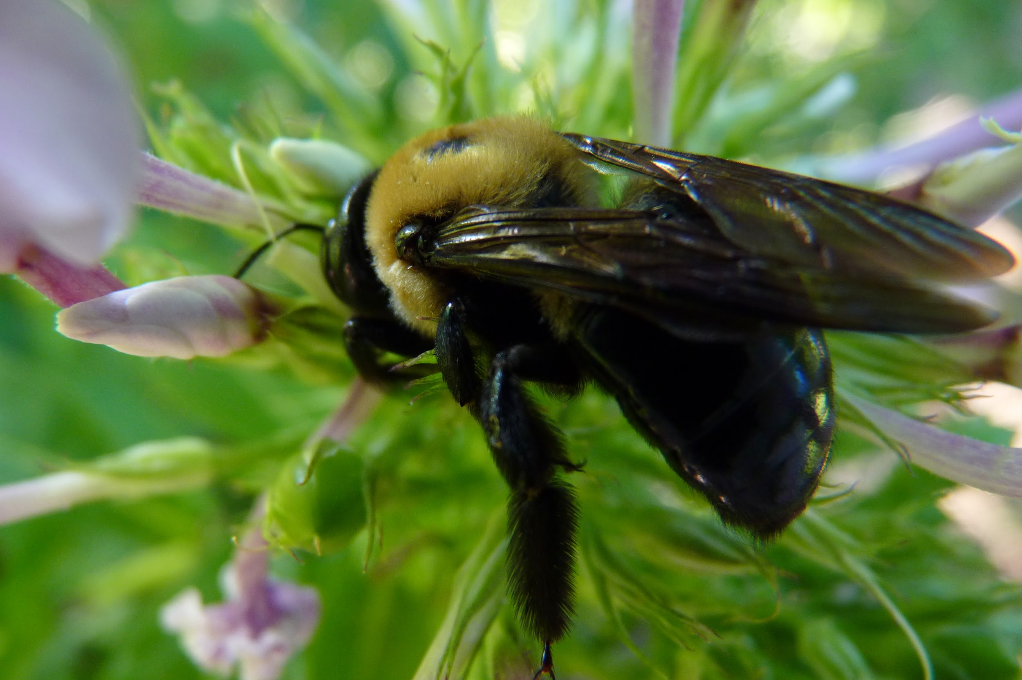  CC BY-NC-SA 2.0 by Dendroica | They burrow into wood to make their homes, and are solitary. They do not live in hives  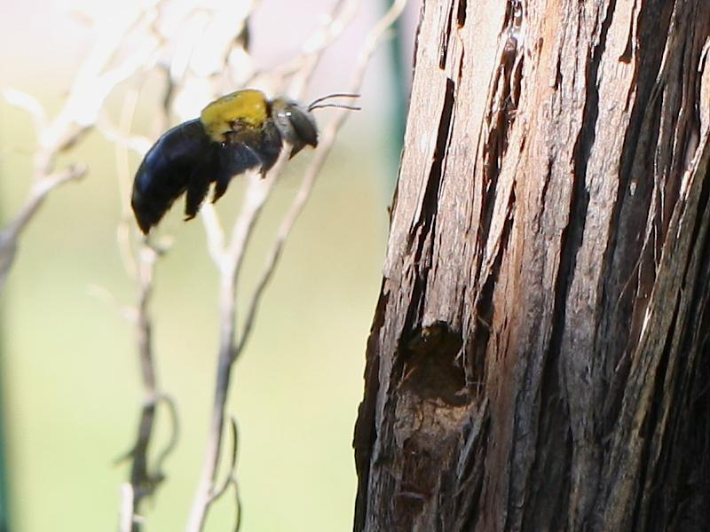  CC BY-NC-SA 2.0 by Malcolm NQ | Some carpenter bees are all black, while others are black and yellow. They are barely bigger than a dime. | Collects pollen and stores it in their burrows. They do not eat wood.
Wasp  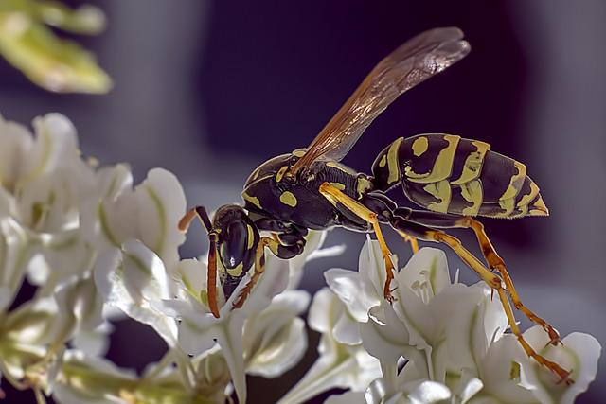  CC BY-NC 2.0 by Artur Rydzewski | Their nests are made from mud, clay, and sometimes paper. They usually make nests in trees, shrubs, or porch roofs.  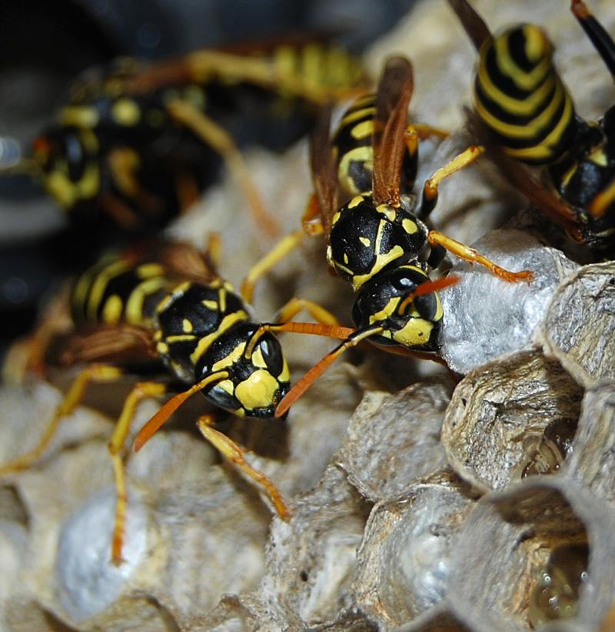  CC BY-NC 2.0 by Roadsidepictures | Have more of an hourglass shape than the traditional bee. Sometimes are reddish in color. | Wasps are both solitary and social. They eat many different insects, including other bees. Like bees, they help the environment by pollinating flowers.
Hornet  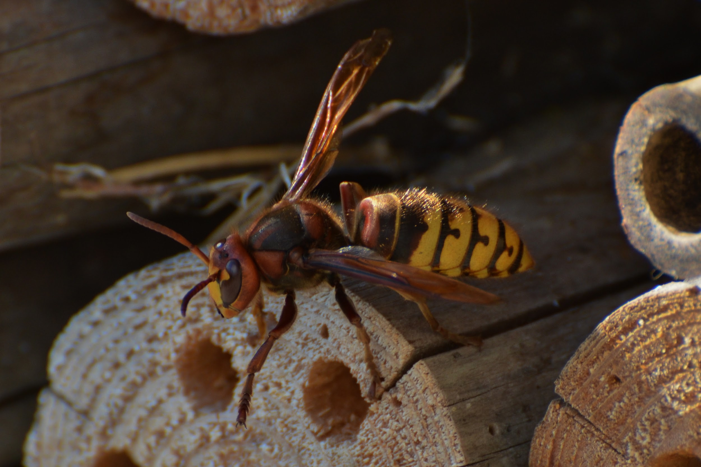  CC BY-NC-SA 2.0 by J Zimmermann | They usually live in the forest. They create their hives by chewing wood and making a papery pulp.  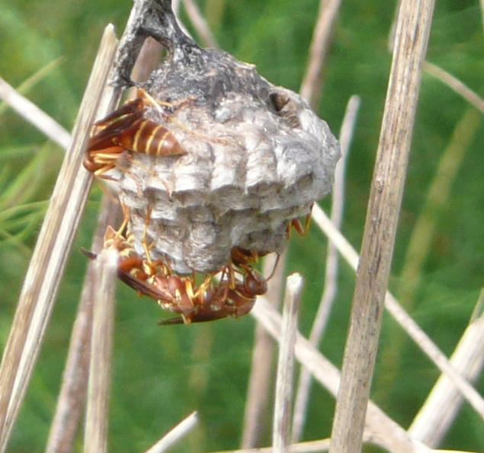  CC BY-NC-SA 2.0 by Dan Irizarry | They are mostly brown with yellow stripes on the abdomen. Can also red and brown | They may startle people at night by flying into windows. Their stings are more dangerous than a traditional bee. They help by balancing the number of insects in our environment.
Yellow Jacket  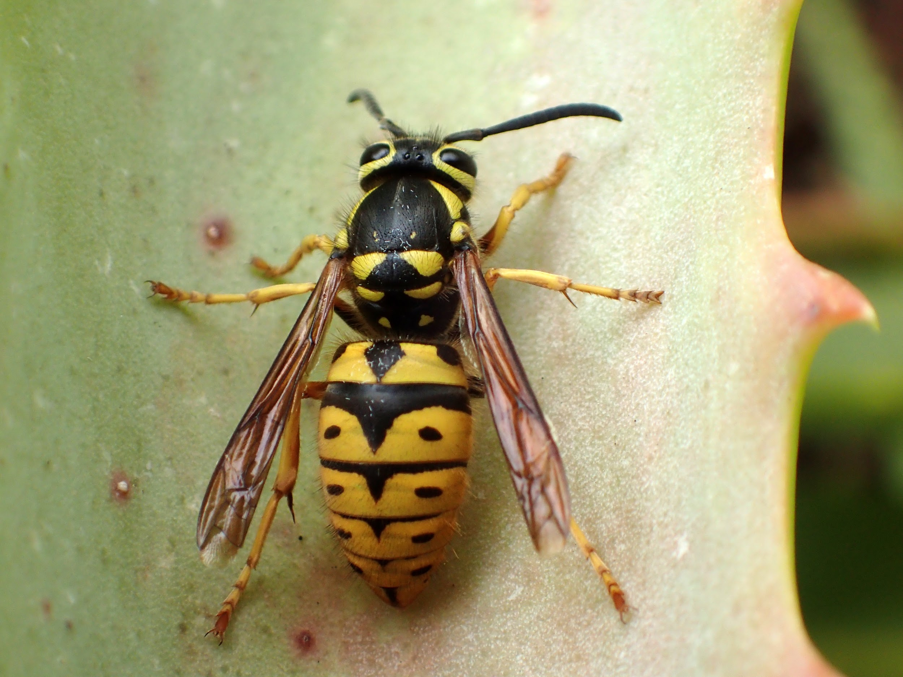  CC BY-NC 2.0 by Bugldy99 | They will make nests in trees, shrubs, or other structures. The nests themselves can become the size of a basketball.  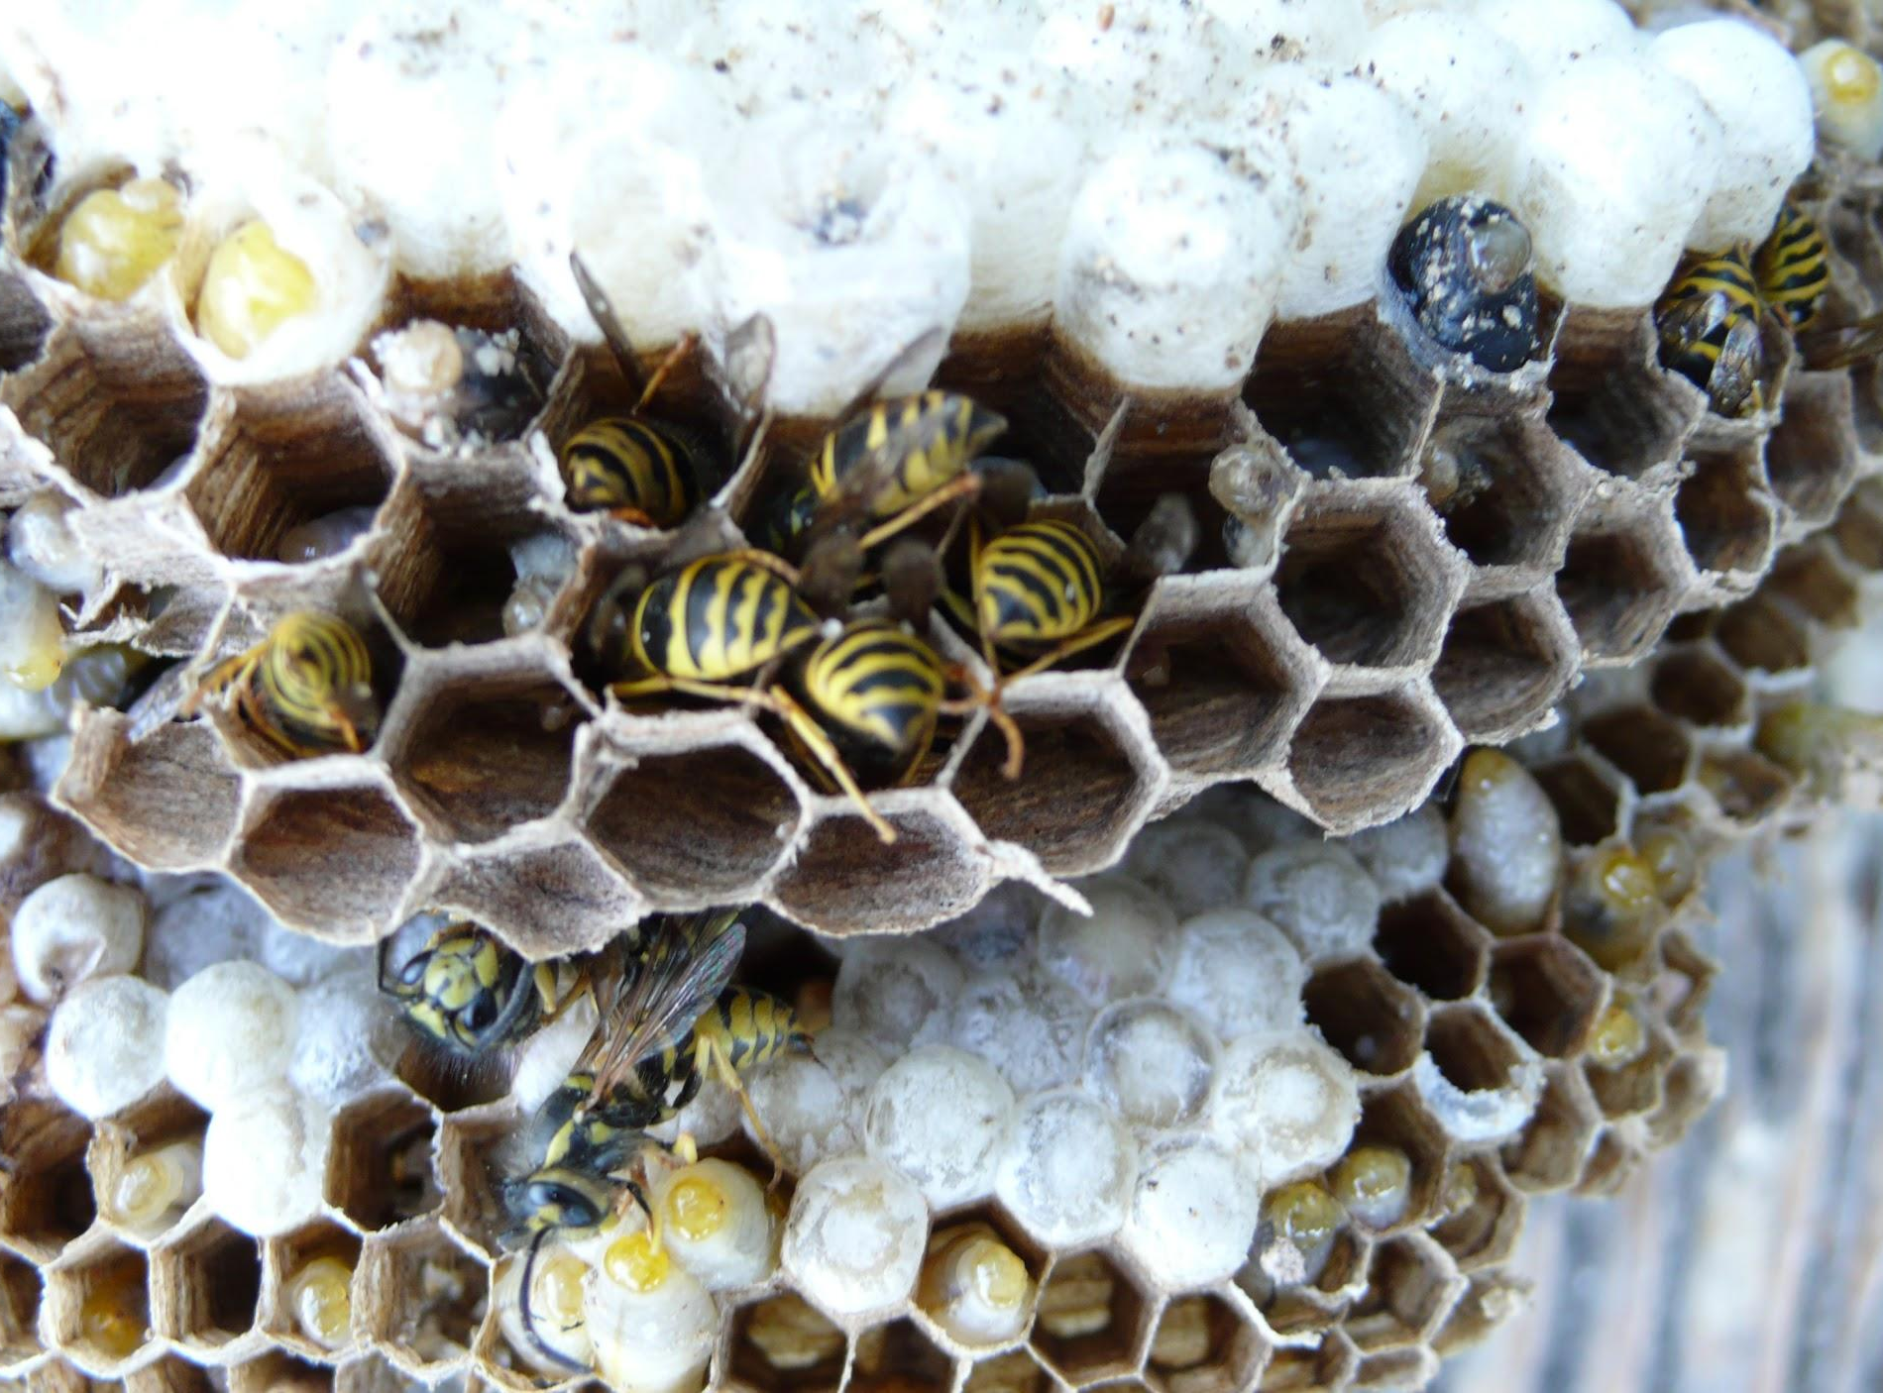  CC BY-NC-SA 2.0 by GeorgiaOnMyMind | Yellow jackets have very specific black and yellow stripes on their abdomen. | Yellow jackets do not collect pollen. They eat other bugs as well as juices from fruit. When threatened, they will become aggressive and sting multiple times. They help by balancing the number of insects in our environment.
Bald Face Hornet  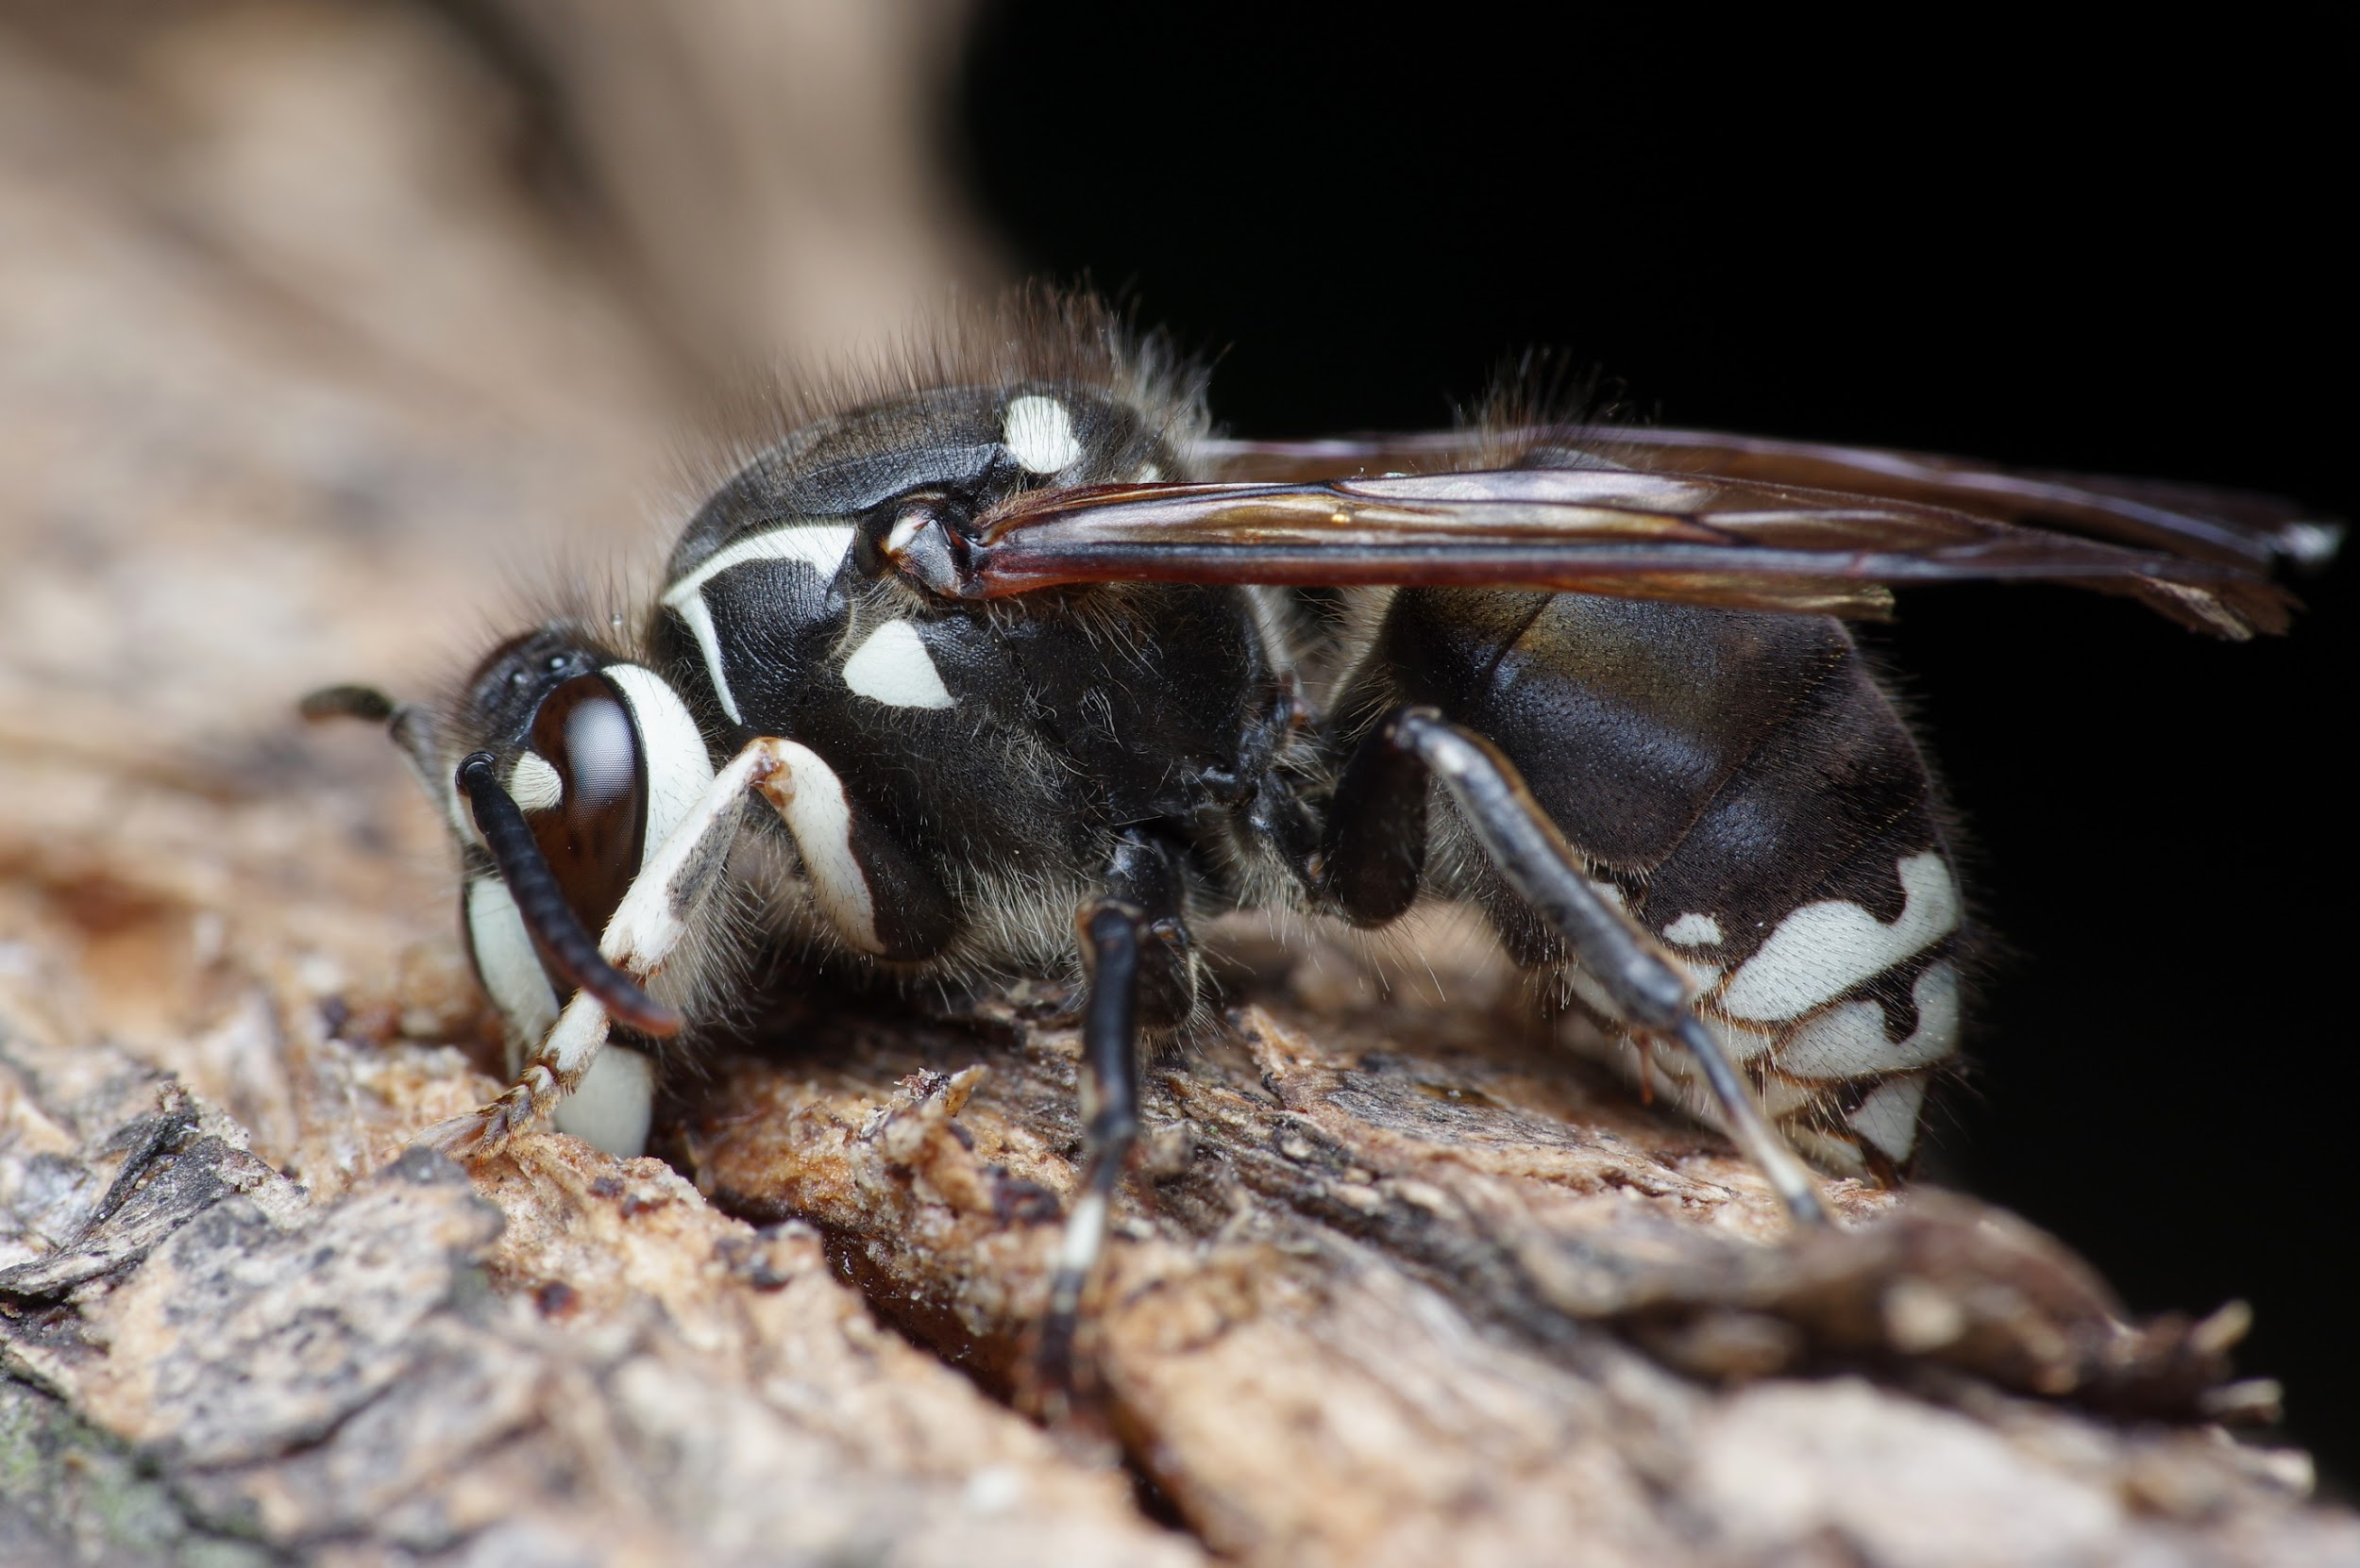  CC BY-NC-SA 2.0 by Doundounba | They make their home out of a paper-like substance. They create their homes in a protective area.  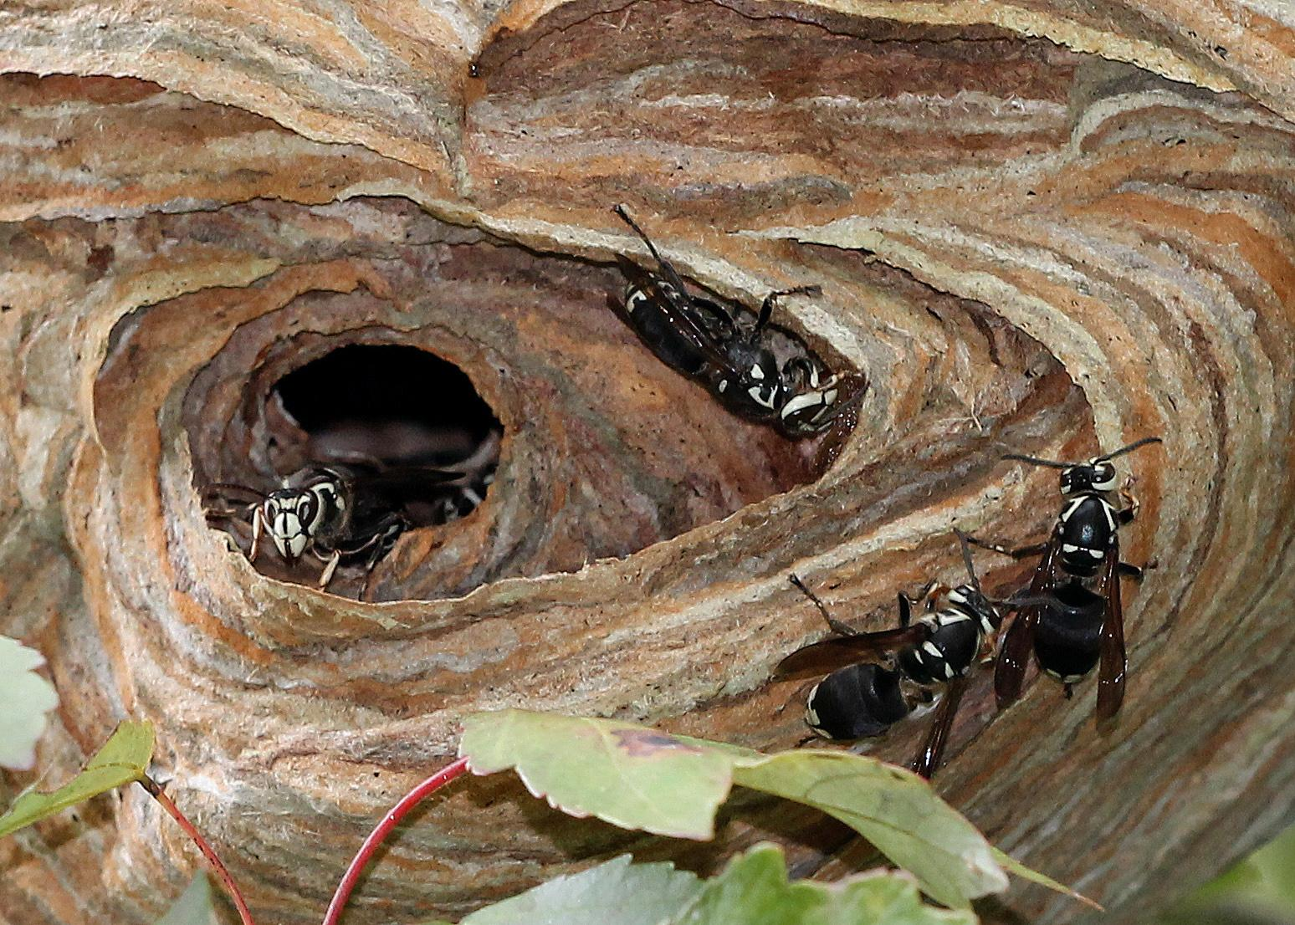  CC BY-NC-SA 2.0 by Mary Keim | Bald face hornets are not hornets, they are a type of yellow jacket. They are called “bald face” because of their white face. | Bald face hornets are very protective of their homes and will sting several times when enemies try to get near them. They can even squirt venom into eyes of foe and cause temporary blindness. They help by balancing the number of insects in our environment.

What Are You Seeing?
Complete the table on the types of bees you see at your school, home, or neighborhood.

What did you see? | Where did you see it? | How many did you see?

All About Solitary Bees

Unlike honey bees and bumblebees, solitary bees do not live in colonies or hives; they like to live by themselves. They are semi-social, which means that although they live alone, they do help each other when it comes to building housing. Solitary bees are fantastic pollinators, but have not received the credit they deserve for their contributions. We need to increase awareness of solitary bees and the benefits they bring to our environment.
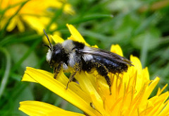

Types of Solitary Bees

Ashy Mining Bee: A ground nesting bee.
Carpenter Bees: Make their nests by creating holes in wood.
Carpenter-Mimic Leafcutter Bee: Makes their nests by collecting leaves and creating a cylinder-shaped tube.
Ashy Mining Bee
CC BY 2.0 by orangeaurochs
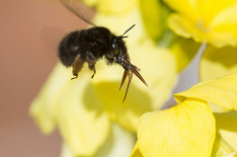
Chocolate Mining Bee: Mainly seen in spring around plants and shrubs.
Hairy Footed Flower Bee: These bees are very hairy, which makes for great pollinating.
Leaf Cutter Bee: Cut pieces of leaves and flowers to use in their housing cells. The largest bee in the world is a solitary leafcutter bee.
Hairy Footed Flower Bee
CC BY-NC-ND 2.0 by KevPBur
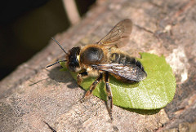
Mason Bee: Use mud to make their nests, and are great pollinators.
Mining Bee: Make their nests underground and are one of the largest known groups of solitary bees.
Nomad Bee: Looks like a wasp and consists of over 850 Nomad bee species all over the world.
Wool Carder Bee: Collects hairs from plants to use in their cells.
Leaf Cutter Bee
CC BY-NC-ND 2.0 by Kentish Plumber

Engineer a Bee Nesting Box
You can design and engineer your own nesting box for solitary bees. The box can be built from common materials you can find in your home. The finished box should be placed in a sunny place.

Materials you CAN use:
Paper straws
Cardboard tubes
Rubber bands
Plastic Water bottles (if there is a material covering the inside)
Wood Scraps

Materials you CANNOT use:
Any paper with a waxy coating (i.e. newspaper or magazines)
Plastic straws
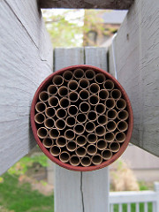
Any plastic that the bees would touch directly
Glue

Example 1: Paper Straw Nesting Can
Fill an empty tin can with paper straws. Cut the straws to be slightly smaller than length of the can. Pack the straws tight together, so if the can was turned upside down, they would not fall out.

CC BY 2.0 by jhritz
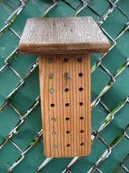
Example 2: Bee Block Nest
Find a block of untreated wood and drill ¼ inch holes in the block. The holes should not go all the way through the block. Glue or nail another small piece of wood on the top, to create a small sloping roof to protect the block nest. Sand the tunnel openings; they need to be smooth and free of splinters. You can place cut paper straws in the tunnels to make the box easier to clean each year.

CC BY-NC-ND 2.0 by anneheathen

Your Design Ideas
Draw out your design for a bee nesting box. Document any materials you will need to build your box and include instructions on how to build your design.

Materials Needed:

Design Notes:

Observe & Collect Bee Data
Observe and collect data on bees in your nesting box, planter box, or garden area.
Date and Time
Temperature
Sunny or Shady?
ft² being observed

Spread out or gathered around a certain plant?
Quantity
Picture/Drawing

Observe & Collect Bee Data
Observe and collect data on bees in your nesting box, planter box, or garden area.
Date and Time
Temperature
Sunny or Shady?
ft² being observed

Spread out or gathered around a certain plant?
Quantity
Picture/Drawing

Observe & Collect Bee Data
Observe and collect data on bees in your nesting box, planter box, or garden area.
Date and Time
Temperature
Sunny or Shady?
ft² being observed

Spread out or gathered around a certain plant?
Quantity
Picture/Drawing

